Anglais

Mail

Gettins-openings-salutations

* Dear Sir/Madam
* Dear Miss, Dear Mrs. Jones
* Mear Mr., Dear Ms. Mx(geneder neutral).
* Dear ms. Jones
* Ms. Jones
* Dear Hiring Manager
* Good morning/afternoon John
* John
* Greetings, Hello, hi ,Hi there, Hey
* To whom it may concern è “A qui de droit”.

Exemple Mail

Subject: Exam missed January 12

Hello/Dear ms. Kinskley

As I wad sick on January 12, I was not able to/unable to attend your class that day and did not take the test.

Please find/You will fund attached the medical certificate wich I hope will excuse my absence.

Could you please let me know I might be able to retake the exam?

I’am sorry for any inconvenience this may cause (you).

Thank you in advance for your understanding.

Best regards

Thomas Pinchon

Groupe 1.

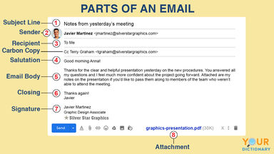

* If we want to “put someone on copy” we use “Carbon copy” or “CC”. But how do we send a secret copy to someone without informing all the recipients? (in French: “cci”)
* Blind Cabon Copy (Bcc).

Int this case, the address doesn’t appear.

Useful abbreviation

* RE: Regarding
* FYI: For Your Information
* ASAP: As soon as possible
* FW/FWD: Forward
* AR: Action required
* EOD/EOW: End of day or End of week
* YTD: Year to date
* PS: Post scriptum
* RSVP: *Répondez s’il vous plaît*
* NRN : No reply necessary
* Y/N : Yes or No
* NBD : Next business day

Parts of an email address

* ‘OOO’ = Out of office
* The ‘Top-Level Domain’
* The email servere and top-level domain (TDL) combine to maje a user’s domain name. The top-level domain tells users what type of organization they are emailing. There are six common top-level domains:
  + .com – Company
  + .edu – Educational institution
  + .gov – Government institution
  + .org – Organization
  + .net – network
  + .mil – military

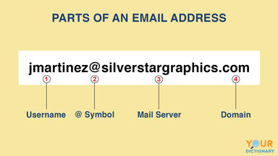

Club-internet.fr.

* *Club hyphen internet dot f are*

Useful vocabulary for emails

What should go into a signature?

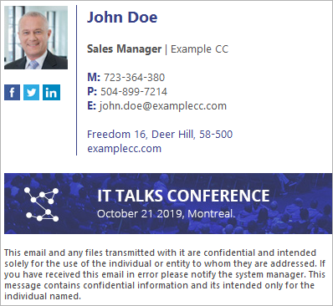

* John Doe => Full name
* John => First name
* Doe => Last name
* Freedom 16, … => Adress
* First name last name/surname
* Title/department
* Mobile/Cell phone number
* Company number
* Email address
* Physical address
* Company logo and name
* Disclaimer.

Exercise





